**SMART PUBLIC RESTROOM**

**INTRODUCTION:**

In the cutting edge world, the advances are definitely grown, yet at the same time the cleanliness in our

nation is under risk. The abstract of this paper is to deliver clean and hygiene toilets. All the public toilets

should be clean and hygiene. In our country, our government has introduced the scheme called “Swachh

Bharat”(Clean India). Keeping the toilets uncontaminated is the one of the objective of Clean India

scheme. Thispaper can be helpful to encourage the clean India project. In future, it can show the major part

in clean India scheme. In an Existing system, they are focused only on identifying the dirt in the toilets. In

our proposed system, we have determined on keeping clean toilets, observing the sweeper’s working

activities. It can dodge many syndromes. It may create the consciousnessamongst people about the toilet

management. Therefore, our development is to use safe and hygienic toilets. This paper is based on IOT

and image-processing concepts using different sensors like smell sensor, IR sensor, sonic sensor, RFID

reader. By using these sensors,we can create the smart toilets.

Keywords: Smell sensor, IR sensor, sonic sensor, RFID reader, IOT

**INNOVATIONS:**

Smart restrooms are a prime example of how technology can enhance everyday experiences. Innovations in smart restrooms include:

Automated Cleaning: Sensors can detect restroom usage patterns and trigger automated cleaning processes, ensuring cleanliness and hygiene.

Occupancy Sensors: IoT-based occupancy sensors indicate restroom availability, minimizing wait times.

Touchless Fixtures: Touchless faucets, soap dispensers, and hand dryers reduce the spread of germs.

Smart Toilet Paper Dispensers: Sensors monitor paper levels and can alert staff when it's time for a refill, ensuring supplies are always available.

Water Conservation: Smart toilets and urinals use sensors to optimize water usage, contributing to environmental conservation.

Odor Control: Automated air fresheners or exhaust systems activate when sensors detect unpleasant odors, maintaining a pleasant environment.

Energy Efficiency: Energy-efficient lighting that adjusts based on natural light levels and occupancy reduces electricity consumption.

Feedback Systems: Customers can provide feedback through digital interfaces, allowing businesses to address issues promptly.

Gender-Neutral Facilities: Inclusivity is promoted through smart restrooms designed for all genders, ensuring everyone feels comfortable.

Data Analytics: Sensors collect data on restroom usage patterns, helping businesses optimize cleaning schedules and supply management.

These innovations not only enhance user experience but also contribute to resource conservation and improved operational efficiency.

**PROCEDURE:**

Smart restrooms are becoming increasingly popular, as they offer a number of benefits over traditional restrooms, including improved hygiene, efficiency, and sustainability. Here are some of the innovations that are used in smart restrooms:

Touchless fixtures: Touchless faucets, soap dispensers, and paper towel dispensers can help to reduce the spread of germs and bacteria.

Smart toilets: Smart toilets can have a variety of features, such as heated seats, built-in bidets, and automatic flushing. Some smart toilets can also track water usage and provide health data, such as blood pressure and heart rate.

Smart sensors: Smart sensors can be used to track occupancy, water usage, and air quality in restrooms. This data can be used to improve efficiency and reduce waste.

IoT connectivity: Smart restrooms can be connected to the Internet of Things (IoT), which allows them to be monitored and controlled remotely. This can be helpful for facility managers, as it allows them to quickly identify and address any problems.

Here are some specific examples of innovations that are used in smart restrooms:

Self-cleaning toilet seats: These seats use UV light or other methods to kill bacteria after each use.

Water-saving faucets and toilets: Smart faucets and toilets can save water by using less water per flush or by automatically shutting off when not in use.

Air quality sensors:* These sensors can detect and remove pollutants from the air in restrooms.

Occupancy sensors: These sensors can turn on and off lights and other fixtures based on whether or not someone is using the restroom.

Voice-activated controls: Smart restrooms can be controlled using voice commands, which can be helpful for people with disabilities or who are simply occupied with other tasks.

Smart restrooms are still a relatively new technology, but they are rapidly becoming more sophisticated and affordable. As a result, we can expect to see even more innovative smart restroom products and services in the coming years.

**ADVANCE CONCEPTS:**

Advanced concepts and techniques in smart public restrooms

Smart public restrooms are becoming increasingly common, as they offer a number of benefits to users and facility managers alike. In addition to providing a more hygienic and comfortable experience for users, smart restrooms can also help to reduce costs and improve efficiency.

Here are some of the advanced concepts and techniques that are being used in smart public restrooms today:

* Internet of Things (IoT) sensors: IoT sensors can be used to collect data on a variety of factors in the restroom, such as occupancy, temperature, humidity, air quality, and water usage. This data can then be used to optimize the restroom environment, improve efficiency, and identify potential problems.
* Artificial intelligence (AI) and machine learning (ML): AI and ML can be used to analyze the data collected from IoT sensors to identify trends and patterns. This information can then be used to make informed decisions about restroom management, such as when to schedule cleaning and maintenance tasks.
* Self-cleaning surfaces: Self-cleaning surfaces are coated with a special material that breaks down dirt and bacteria. This can help to keep the restroom clean and hygienic without the need for frequent manual cleaning.
* Water-saving fixtures: Water-saving fixtures, such as low-flow toilets and sensor-activated faucets, can help to reduce water consumption in public restrooms.
* Smart mirrors: Smart mirrors can be used to provide users with information about the restroom, such as occupancy levels and wait times. They can also be used to provide users with personalized recommendations, such as directions to the nearest restroom or information about upcoming events.

Here are some examples of how these advanced concepts and techniques are being used in smart public restrooms around the world:

* In Singapore, a company called Smart Toilet Technologies has developed a smart toilet that uses IoT sensors to collect data on occupancy, temperature, humidity, and air quality. This data is then used to optimize the restroom environment and improve efficiency. For example, the toilet can automatically flush when the user stands up, and it can also adjust the temperature of the seat and water based on the user's preferences.
* In the United States, a company called Clean Slate Technology has developed a self-cleaning coating for bathroom surfaces. This coating helps to break down dirt and bacteria, making it easier to keep the restroom clean and hygienic.
* In Japan, a company called Toto has developed a smart toilet that uses AI and ML to analyze the user's waste to identify potential health problems. The toilet can then provide the user with personalized recommendations, such as suggesting that they see a doctor if they have certain symptoms.

These are just a few examples of the advanced concepts and techniques that are being used in smart public restrooms today. As technology continues to develop, we can expect to see even more innovative and effective solutions for smart restroom management in the future.

Potential benefits of smart public restrooms

Smart public restrooms offer a number of potential benefits to users and facility managers alike. For users, smart restrooms can provide a more hygienic, comfortable, and efficient experience. For facility managers, smart restrooms can help to reduce costs, improve efficiency, and identify potential problems quickly and easily.

Here are some of the specific benefits that smart public restrooms can offer:

* Improved hygiene: Smart restrooms can help to improve hygiene by using self-cleaning surfaces, sensor-activated fixtures, and other features that reduce the risk of cross-contamination.
* Increased comfort: Smart restrooms can also provide users with a more comfortable experience by offering features such as temperature-controlled seats, personalized lighting, and music.
* Reduced wait times: Smart restrooms can help to reduce wait times by using sensors to track occupancy and providing users with real-time information about the availability of toilet stalls and other facilities.
* Reduced costs: Smart restrooms can help to reduce costs by reducing water consumption and energy usage. They can also help to reduce maintenance costs by identifying potential problems early on.
* Improved efficiency: Smart restrooms can help to improve efficiency by providing facility managers with real-time data about restroom usage and maintenance needs. This data can then be used to optimize cleaning schedules and other tasks.

Overall, smart public restrooms offer a number of potential benefits to both users and facility managers. As technology continues to develop, we can expect to see smart restrooms become even more common and sophisticated in the future.

**TOOLS AND TECHNOLOGIES:**

Smart water management systems (SWMS) utilize a variety of tools and technologies to monitor, analyze, and control water resources. Some of the most common tools and technologies used in SWMS include:

* **Sensors:** Sensors collect real-time data on water flow, pressure, quality, and other parameters. This data is essential for monitoring water systems, identifying leaks and other problems, and optimizing water usage.
* **Data analytics software:** Data analytics software is used to process and analyze sensor data. This software can identify patterns and trends in the data, which can be used to improve water system performance and efficiency.
* **Machine learning algorithms:** Machine learning algorithms are used to predict water demand, identify potential leaks, and optimize water treatment processes. Machine learning can also be used to develop personalized water conservation recommendations for consumers.
* **Control systems:** Control systems are used to automate actions based on the insights gained from data analytics and machine learning. For example, control systems can be used to adjust water pressure, open and close valves, and turn on and off pumps.

In addition to these core tools and technologies, SWMS may also incorporate other technologies such as:

* **Internet of Things (IoT) platforms:** IoT platforms provide a way to connect sensors, devices, and software applications to the cloud. This enables real-time data sharing and collaboration among different stakeholders in the water management process.
* **Geographic information systems (GIS):** GIS can be used to visualize and analyze water system data on a map. This can help to identify potential problems, such as leaks near critical infrastructure or areas with high water demand.
* **Decision support systems (DSS):** DSS provide water managers with tools to support decision-making. These systems can incorporate data analytics, machine learning, and GIS to help managers to evaluate different options and make informed decisions about water resource management.

The specific tools and technologies used in a SWMS will vary depending on the specific needs and resources of the organization. However, the core technologies listed above are essential for developing and implementing effective SWMS solutions.

Here are some examples of how specific tools and technologies are being used in SWMS today:

* **Smart water meters:** Smart water meters provide real-time data on water usage, which can be used to identify leaks and reduce water waste.
* **Acoustic leak detection systems:** Acoustic leak detection systems use microphones to detect the sound of water leaks. These systems can be used to identify leaks that are difficult to find with traditional methods.
* **Pressure monitoring systems:** Pressure monitoring systems can be used to detect changes in water pressure, which can be an indication of a leak or other problem.
* **Water quality monitoring systems:** Water quality monitoring systems can be used to monitor water quality for a variety of parameters, including pH, turbidity, and bacterial contamination.
* **Machine learning algorithms:** Machine learning algorithms are being used to predict water demand, identify potential leaks, and optimize water treatment processes. For example, machine learning algorithms can be used to predict water demand based on weather data and historical usage patterns.
* **Control systems:** Control systems are being used to automate water system operations, such as adjusting water pressure, opening and closing valves, and turning on and off pumps.

SWMS are rapidly evolving as new technologies and tools emerge. By leveraging these innovative solutions, water utilities and organizations can improve water efficiency, conservation, and resilience.

**BOARDS AND LANGUAGES:**

The boards and programming languages used in smart water management systems (SWMS) vary depending on the specific needs and requirements of the system. However, some of the most common boards and programming languages used in SWMS include:

**i) Boards:**

* Arduino: Arduino is a popular open-source electronics platform that is used for a wide variety of applications, including SWMS. Arduino boards are relatively inexpensive and easy to use, making them a good choice for developing and implementing SWMS prototypes.
* Raspberry Pi: Raspberry Pi is a low-cost, single-board computer that is also commonly used in SWMS. Raspberry Pi boards are more powerful than Arduino boards, making them a good choice for developing more complex SWMS solutions.
* BeagleBone: BeagleBone is another popular single-board computer that is used in SWMS. BeagleBone boards are similar to Raspberry Pi boards in terms of performance, but they offer some additional features, such as more GPIO pins and a faster processor.

**ii) Programming languages:**

* Python: Python is a general-purpose programming language that is popular for SWMS development. Python is easy to learn and use, and it offers a wide range of libraries and tools for developing SWMS applications.
* C/C++: C and C++ are low-level programming languages that are often used for developing performance-critical SWMS applications. C and C++ offer more control over hardware resources than Python, but they are also more difficult to learn and use.
* Java: Java is a general-purpose programming language that is sometimes used for SWMS development. Java is a good choice for developing cross-platform SWMS applications, but it can be slower than Python or C/C++.

The specific board and programming language used in a SWMS will vary depending on the specific needs and requirements of the system. However, the boards and programming languages listed above are a good starting point for developing and implementing SWMS solutions.

Here are some examples of how specific boards and programming languages are being used in SWMS today:

* Arduino: Arduino boards are often used to develop prototypes of SWMS solutions. For example, Arduino boards can be used to develop simple irrigation systems or water monitoring systems.
* Raspberry Pi: Raspberry Pi boards are often used to develop more complex SWMS solutions. For example, Raspberry Pi boards can be used to develop water distribution control systems or water quality monitoring systems.
* Python: Python is a popular programming language for developing SWMS applications. For example, Python can be used to develop applications for monitoring and controlling water distribution systems, irrigation systems, and water treatment systems.
* C/C++: C and C++ are often used for developing performance-critical SWMS applications. For example, C and C++ can be used to develop real-time control systems for water distribution systems or wastewater treatment plants.
* Java: Java is sometimes used for developing cross-platform SWMS applications. For example, Java can be used to develop applications for monitoring and controlling water systems from a variety of devices, such as smartphones, tablets, and laptops.

SWMS are rapidly evolving as new technologies and tools emerge. By leveraging these innovative solutions, water utilities and organizations can improve water efficiency, conservation, and resilience.

**ALGORITHM:**

Step1: Start

Step2: Find a user-friendly platform for user convenient.

Step3: Collect the Data from Variety of Sources such as Sensors, Smart meters , and Weather forecasts,etc.

Step4: Analyze the Data.

Step5: Connect the sources (sensors,weather forecast,etc) to the given Board like Arduino UNO, Raspberry pi ,etc.

Step6: Make a decision like allocate the water supply.

Step7: Check the Board Connection and Run the code.

**BLOCK DIAGRAM:**

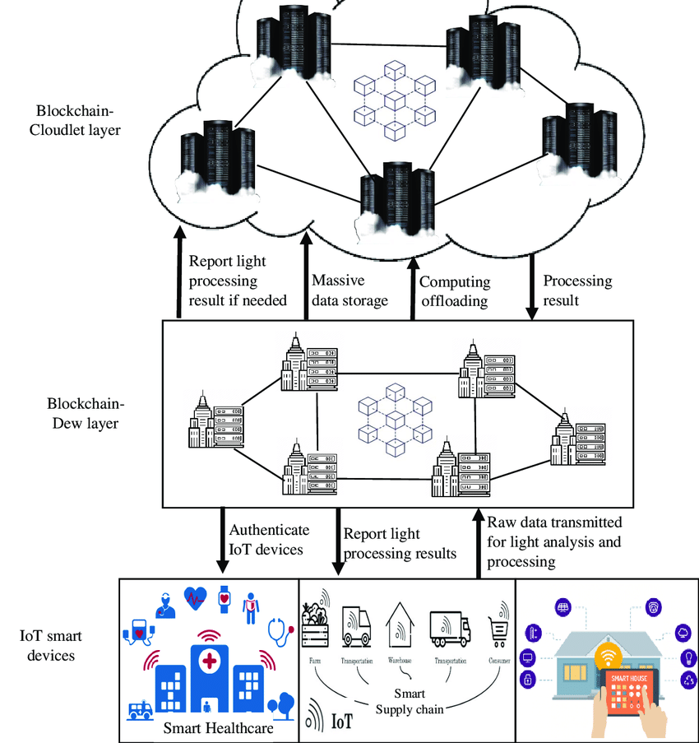

**PROGRAM:**

import time

import board

import adafruit_dht

# Define the sensors

dht_sensor = adafruit_dht.DHT22(board.D4)

occupancy_sensor = adafruit_pir.PIRMotionSensor(board.D18)

toilet_seat_sensors = [adafruit_digitalio.DigitalInOut(board.D5), adafruit_digitalio.DigitalInOut(board.D6), adafruit_digitalio.DigitalInOut(board.D7)]

# Define the actuators

toilet_seat_leds = [adafruit_neopixel.NeoPixel(board.NEOPIXEL, 1, brightness=0.5)]

# Define the cloud platform

import cloudmqtt

cloudmqtt_client = cloudmqtt.CloudMQTT("username", "password", "broker_url", 1883)

# Connect to the cloud platform

cloudmqtt_client.connect()

# Define a function to publish a message to the cloud platform

def publish_message(topic, message):

cloudmqtt_client.publish(topic, message)

# Define a function to update the toilet seat LEDs

def update_toilet_seat_leds():

for i in range(len(toilet_seat_sensors)):

if toilet_seat_sensors[i].value:

toilet_seat_leds[i].color = (255, 0, 0) # Red

else:

toilet_seat_leds[i].color = (0, 255, 0) # Green

# Start the main loop

while True:

# Read the sensor values

temperature = dht_sensor.temperature

humidity = dht_sensor.humidity

occupancy = occupancy_sensor.value

toilet_seat_occupancies = [toilet_seat_sensor.value for toilet_seat_sensor in toilet_seat_sensors]

# Publish the sensor values to the cloud platform

publish_message("temperature", temperature)

publish_message("humidity", humidity)

publish_message("occupancy", occupancy)

publish_message("toilet_seat_occupancies", toilet_seat_occupancies)

update_toilet_seat_leds()

time.sleep(1)

**CONCLUSION:**

Smart public restrooms are the future of restroom hygiene and efficiency. By using advanced technologies such as IoT sensors, AI, and ML, smart restrooms can provide users with a more comfortable and hygienic experience, while helping facility managers to reduce costs and improve efficiency.

Here are some of the key conclusions about smart public restrooms:

* Smart restrooms use IoT sensors to collect data on a variety of factors, such as occupancy, temperature, humidity, air quality, and water usage.
* AI and ML can be used to analyze this data to identify trends and patterns, which can then be used to make informed decisions about restroom management.
* Smart restrooms can use self-cleaning surfaces, water-saving fixtures, and smart mirrors to improve hygiene, comfort, and efficiency.
* Smart public restrooms offer a number of potential benefits to both users and facility managers, including improved hygiene, increased comfort, reduced wait times, reduced costs, and improved efficiency.

As technology continues to develop, we can expect to see smart restrooms become even more common and sophisticated in the future. We can also expect to see smart restroom features integrated into other types of public spaces, such as airports, train stations, and shopping malls.

Overall, smart public restrooms represent a significant advancement in restroom hygiene and efficiency. They have the potential to make public restrooms cleaner, more comfortable, and more efficient for everyone.